**SPRINT 2 MAKEUP**

TEAM 2

PENN STATE UNIVERSITY – ABINGTON

IST 412 – FALL 2023

PROF. JIM CLARKE

**TEAM MEMBERS:**

Alexis Nicole Rowland

Johnathan Jason Leopold

Xavier Cruz

Ali Alzaidi

**Table of Contents**

1. **Sprint Summary Metrics**
   1. Summary Metrics Chart
   2. Summary Metrics Graph
2. **Deliverables**
   1. Database Design and Structure
   2. Wireframing and Design
   3. Accountability
   4. User Stories and Trello
3. **Retrospective**
4. **Product Backlog Summary**

**Sprint Summary Metrics: (SPRINT 1+2)**

|  |  |  |  |  |
| --- | --- | --- | --- | --- |
| **SPRINTS** | **USER STORIES CREATED (TOTAL)** | **USER STORIES IN PROGRESS** | **USER STORIES COMPLETED** | **USER STORIES CARRIED INTO NEXT SPRINT** |
| **S1** | 7 | 1 | 2 | 6 |
| **S2** | 10 | 2 | 2 | 8 |
| **S3** | N/A | N/A | N/A | N/A |

**Deliverables:**

1. **Database Design and Structure**
   1. While assessing each other’s strengths and weaknesses, we allocated certain team members to focus on our vision of the database. The ability to see inventory, customer data, movie data, rental status, and a few other features. The team working on the database constructed a small, organized diagram to determine requirements.

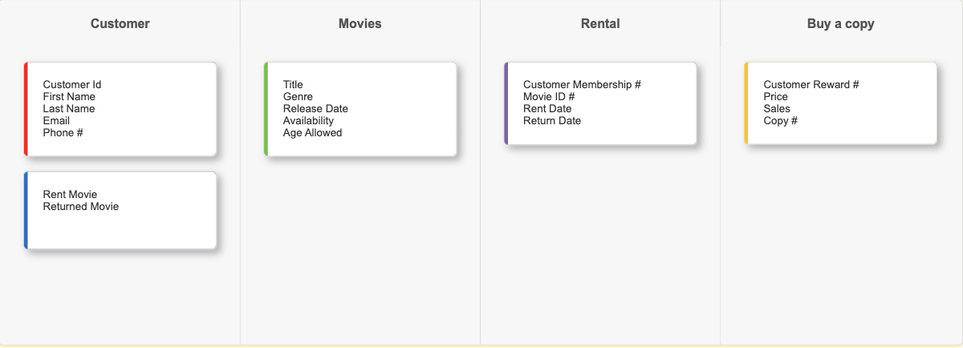

1. **Wireframing and Design**
   1. 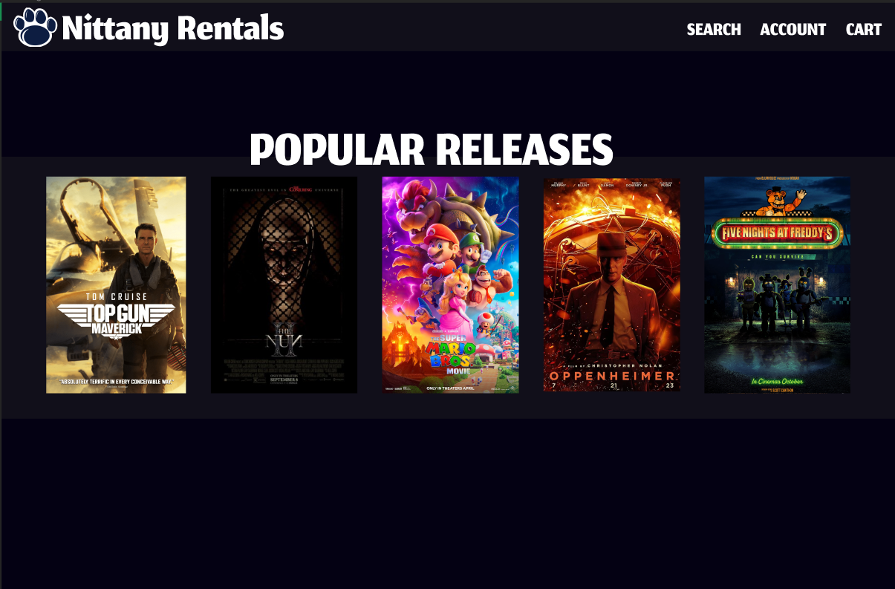Wireframing and design has begun for the planned home page and movie pages which show the details of the selected film. Once finished through the program Figma, CSS code will be extracted and uploaded. Screenshots of progress have been uploaded below.

Figure 1: Home Page of Nittany Rentals

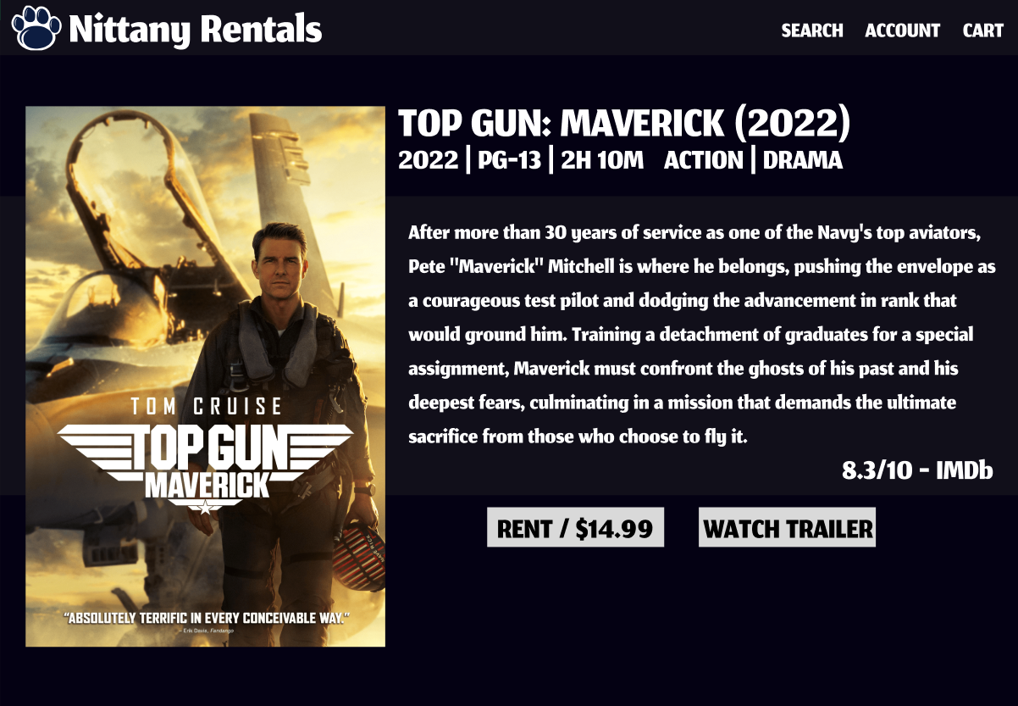

Figure 2: Top Gun: Maverick Film Details

1. **Accountability**
   1. The team has been working on making up submissions for the Accountability documents throughout the weeks. As one teammate hasn’t been in contact with us through the entire semester, we made sure to make comments about it within the accountability documents.
2. **User Stories and Trello**
   1. More team members have been added to the Trello space which we are using instead of the recommended Azure DevOps. More user stories have been added as the project is further developed and is regularly updated according to our needs and progress. Screenshots will be provided in the Product Backlog Summary.

**Retrospective:**

The team is still doing extremely well with trying to make up for the time lost in confusion with the project. Everyone’s access to the Trello is helping with understanding what needs to be done in order of priority, etc. The progress is going extremely well, and we hope to have everything completed or close to completed by the first week of December.

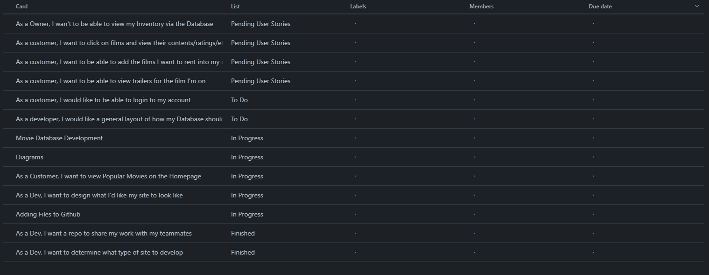**Product Backlog summary by sprint:**